2021 Community Practice Medication Safety Modules

Course overview: This course is designed to provide you with the education and training you will need for your role as a Medical Assistant (MA). The course contains lessons on, Medication Safety & Administration, Injection Site Locations, Comfort Holds, Vaccines and more. It includes relevant images, examples and key context to guide you through the curriculum.

How to access the module:

Internal to Nationwide Children’s Hospital:
Please log into the Learning Center and search for this course: NCH 2021 Community Practice Medication Safety and click Enroll.

Length of time: approximately one hour to complete

CME credit (optional): information provided at the end of the module

External to Nationwide Children’s Hospital:
- Community user site: https://NationwideChildrens.csod.com/selfreg/register.aspx?c=%255e%255e%255ekN8eT%252bOkl6NfCOXPEVUGkA%253d%253d

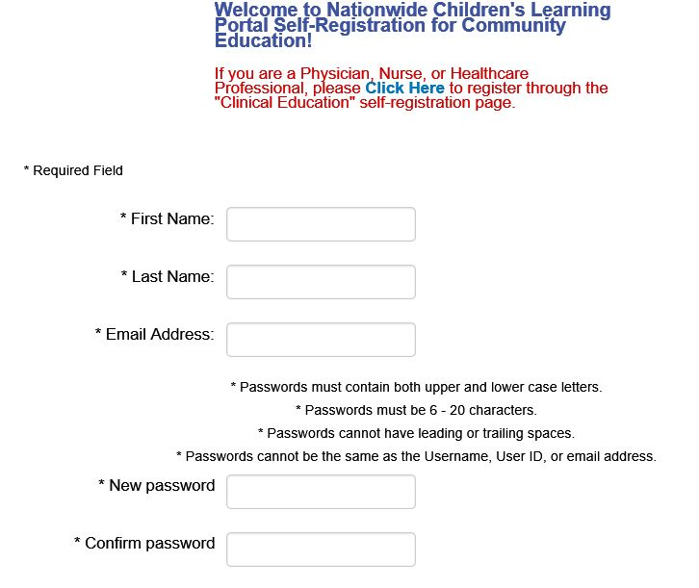

- Self-register for access:
  - Enter your first and last name
  - Enter your email address
- Create and confirm your password.
- Click in the “I’m not a robot” box to complete your registration.
- Once you’ve created your username and password, you can scroll down and click the Login Here link.
- Select Login In.
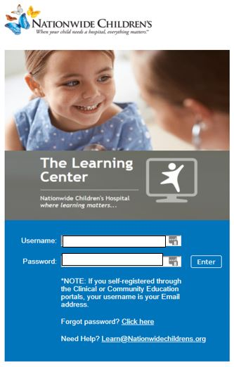
- Enter your email as your Username, enter the Password you created and click Enter.
- The Home page will open, search for your course by date or title: 2021 Community Practice Medication Safety.
- From the search results, click the Course link.
- On the training details page, click Launch.
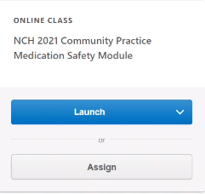

- Your course transcript will appear, locate your course, click the Open Curriculum drop-down arrow and select View Training Details at the bottom of the screen.
- Click Evaluate by the Test Type to launch the evaluation. Do you want the evaluation tied to the course? If so, you will need to go back to the transcript to complete the evaluation. If not, complete the evaluation in the CME tracker.
  - Click Continue and complete the evaluation.
  - Click Submit Final Answers to complete the course.
- To view and print your course completion certificate
(NOTE: This is not a CME Certificate)
  - Click Learning on the top menu, then View Transcript.
  - Click on the Active button and select Completed.
  - Locate your completed course, click View Certificate and print if needed.

To View Your Learning Center Transcript
From the Learning Center Welcome screen
- Click View Transcript.
- Click the Active button and select Completed.
- You will see a list of your completed courses. You can choose to print this list. Or you can view each certificate and print them if you need to turn them in for reporting purposes.

NOTE: This is not your Nationwide Children’s Hospital CME credit transcript. It will take 30 – 45 days for CME credit to appear on the Nationwide Children’s CME credit transcripts. To access your Nationwide Children’s CME credit transcript, follow the instructions found at http://ANCHOR.ColumbusChildrens.net/continuing-medical-education-cme-transcript-center

Length of time: approximately one hour to complete

CME credit (optional): information provided at the end of the module

Thank you for participating in our pilot process for MA education!
Please access this link at https://www.surveymonkey.com/r/8BZQKXW to provide feedback on how we can improve to make this education better for you.

